**Input and Output of This Program**

**Main Page**

1. **User enter type of user**
   1. 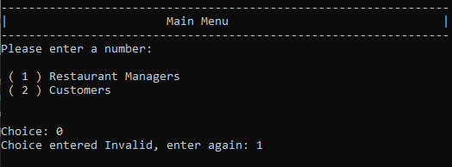**Input Validation**
2. **Go to Manager Page**
   1. **Input Validation**

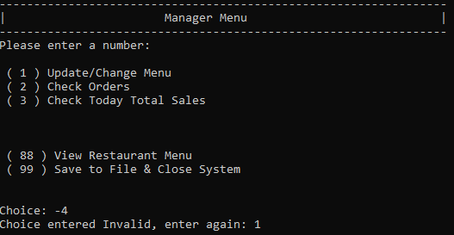

1. **Go to Customer Page**
   1. **Input Validation**

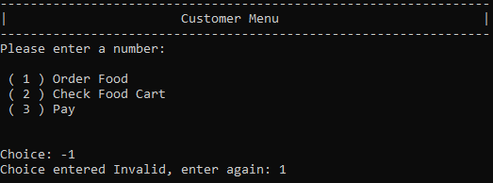

**Manager Part**

1. **Update Page**

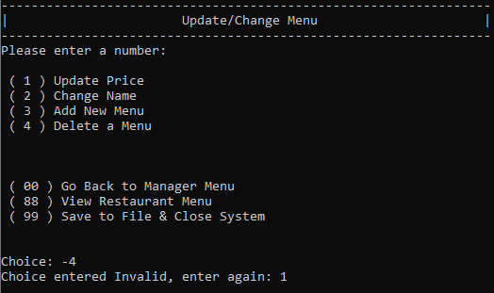**Input Validation**

* 1. **Update Price**

**Input Validation**

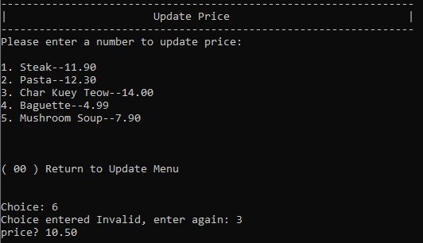

**Price updated in Menu**

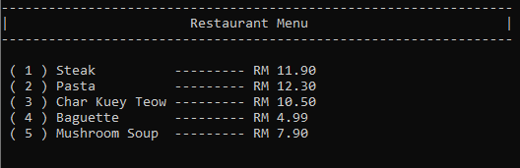

* 1. **Update Name**

**Input Validation**

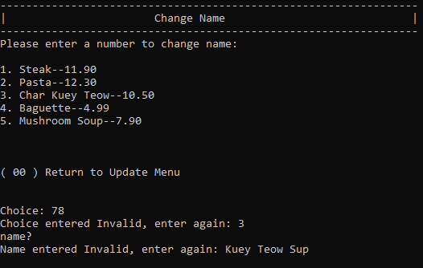

**Name updated in Menu**

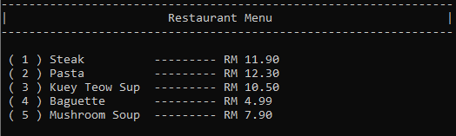

* 1. **Add Menu**

**Input Validation**

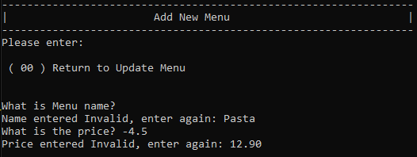

**Menu added**

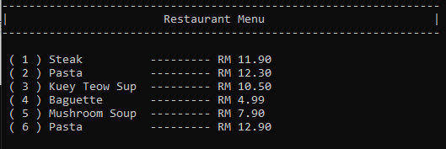

* 1. **Delete Menu**

**Input Validation**

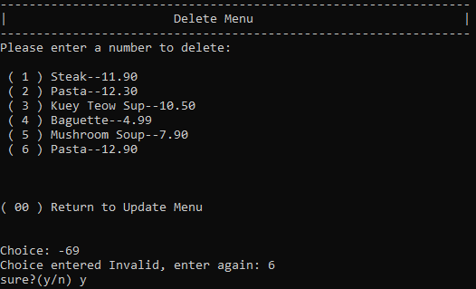

**Menu Deleted from List**



1. **Check Order**

**Input Validation**

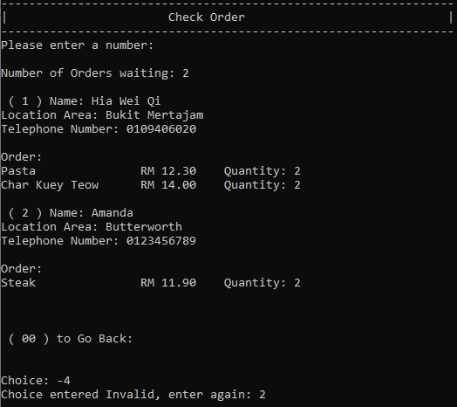

**Order has been delivered**

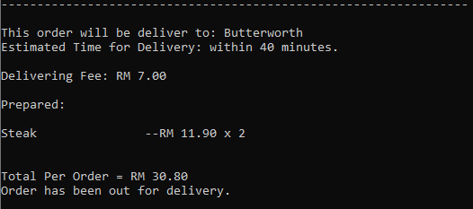

1. **Check Total Sales**

**Print number of order finished and total sales**

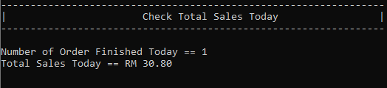

1. **Save Files and Close System**

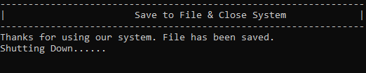

**Customer Part**

1. **Order Food**

**Input Validation**

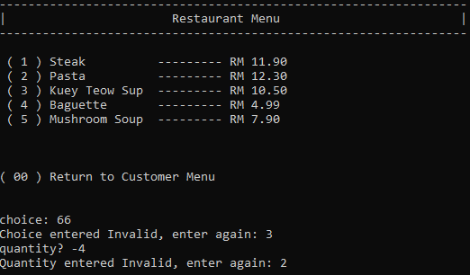

1. **Check Food Cart**

**Input Validation**

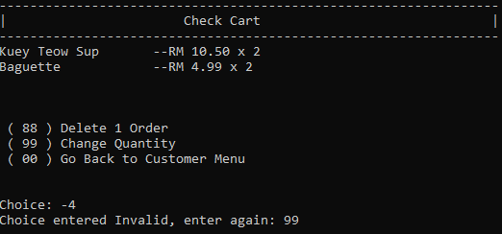

* 1. **Change Food Quantity**

**Input Validation**

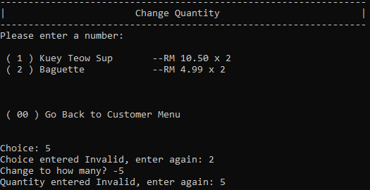

**Quantity is changed in cart**

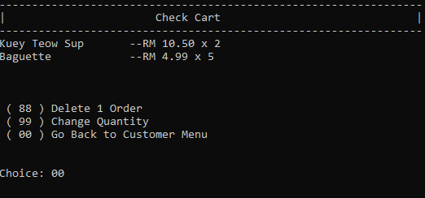

* 1. **Delete Food Order**

**Input Validation**

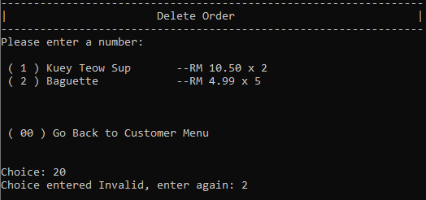

**Food is Deleted in Cart**

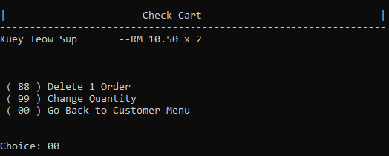

1. **Pay Order**

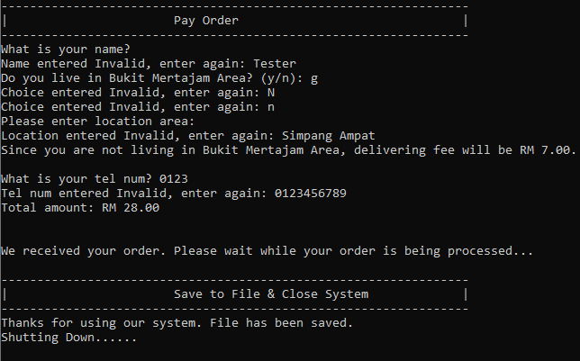**Input Validation**